Low Level Design – Dhara Module
Project: Jal Rekha
Module: Dhara – Water Supply & Meter Reading

1. Introduction
The Dhara Module is a core component of the Jal Rekha system designed to manage water supply meter surveys and reporting. The module supports mobile-based data capture by Field Engineers and web-based validation, editing, approval, and reporting by the General Manager.

2. System Architecture Overview
2.1 Technology Stack
- Frontend: ASP.NET (Web Dashboard, GIS Visualization)
- Mobile Application: Android (Core Java/Kotlin)
  - Offline Sync using SQLite / Local Storage
- Backend: RESTful WCF Services (.NET)
- Database: PostgreSQL with PostGIS (Spatial Data)
2.2 Infrastructure & Security
- Web Server: IIS
- Authentication: JWT Tokens
- Authorization: Role-Based Access Control (RBAC)

Hosting: In-House Cloud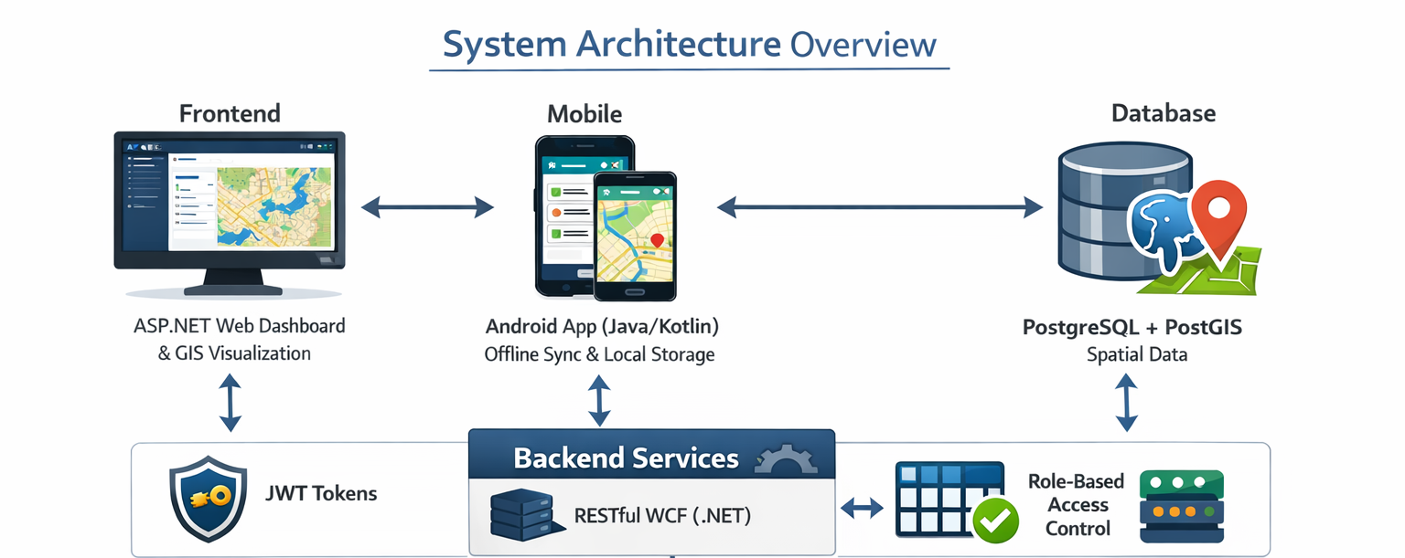

3. Objective
The objective of the Dhara Module is to ensure accurate collection, validation, and approval of water supply meter readings through a controlled, role-based workflow and to generate reliable operational reports.

4. Actors / User Roles
General Manager (GM):
- Assigns survey tasks
- Reviews submitted readings
- Edits readings with remarks
- Approves or rejects surveys
- Views and downloads reports
Field Engineer (FE):
- Receives survey tasks
- Submits meter readings and survey data through mobile application

5. Pre-Requisite Modules (Web Based)
- Assign Work & Asset Mapping
- Scheme to Village Mapping
- OHT to Village & Habitation Mapping

6. Functional Workflow
6.1 Task Assignment:
- GM selects Scheme, Village, and OHT from mapped data
- GM assigns survey task to FE
6.2 Survey Execution (Mobile):
- FE logs in to mobile application
- FE submits Intake, WTP, OHT, and Bulk Meter readings
- Survey data is synced to the web portal
6.3 Review & Approval (Web):
- GM views submitted survey data
- GM edits incorrect readings with mandatory remarks
- GM approves or rejects the survey

7. Screen Details (Web)
Dhara Assign Task Screen:
- Scheme dropdown
- Component dropdown
- FE selection
- Assign Task button
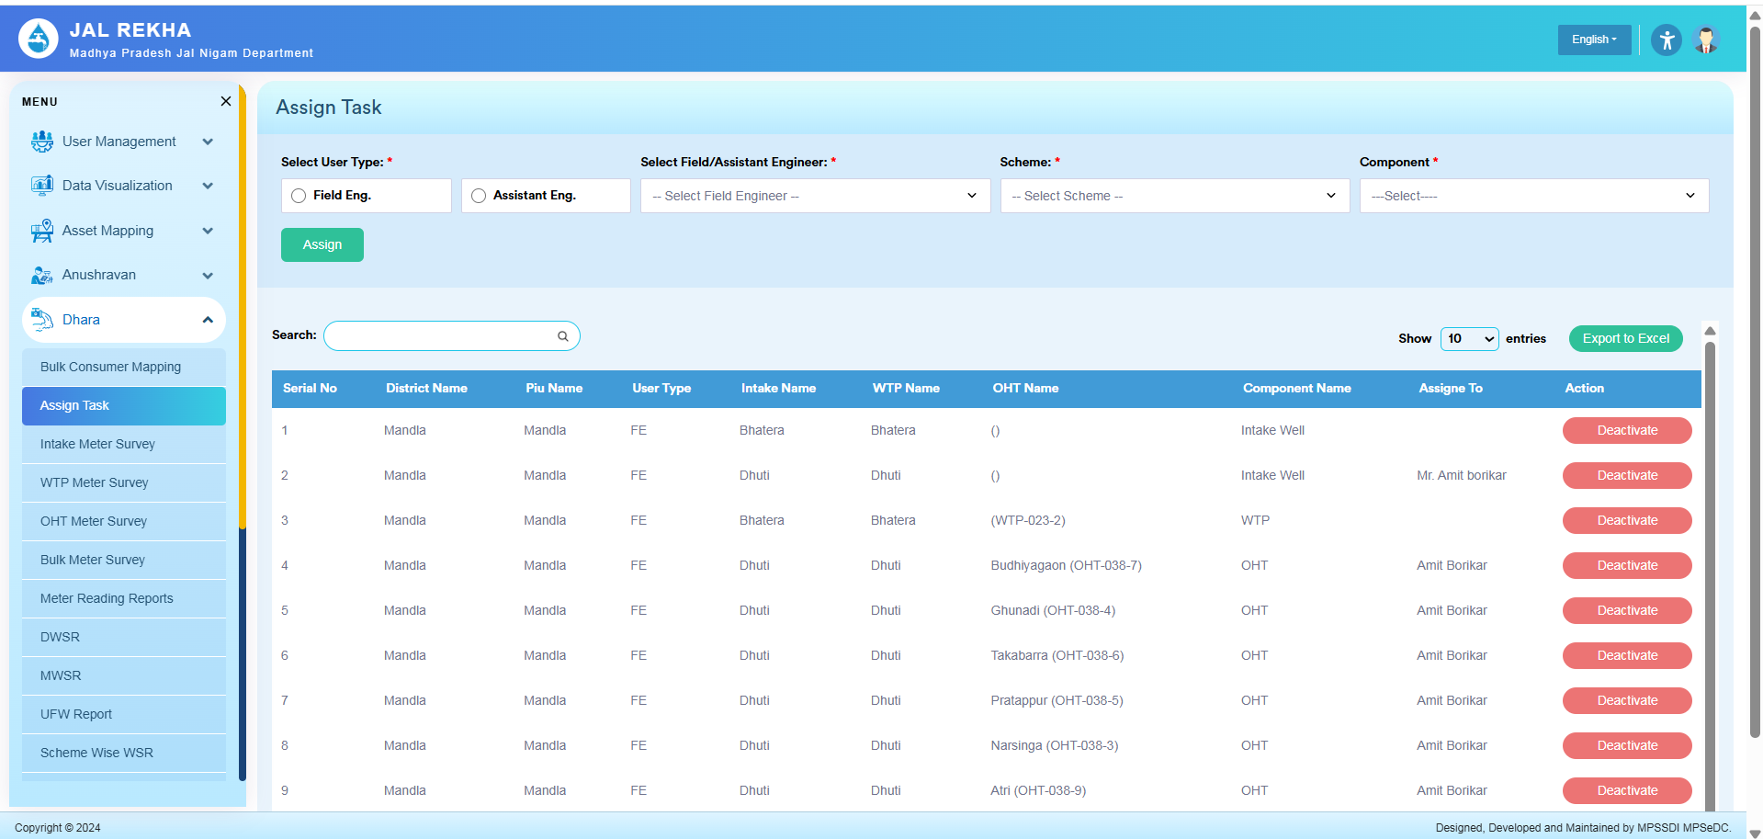
Survey Review Screen:
- Survey details view
- Edit reading option
- Remark field
- Approve / Reject buttons
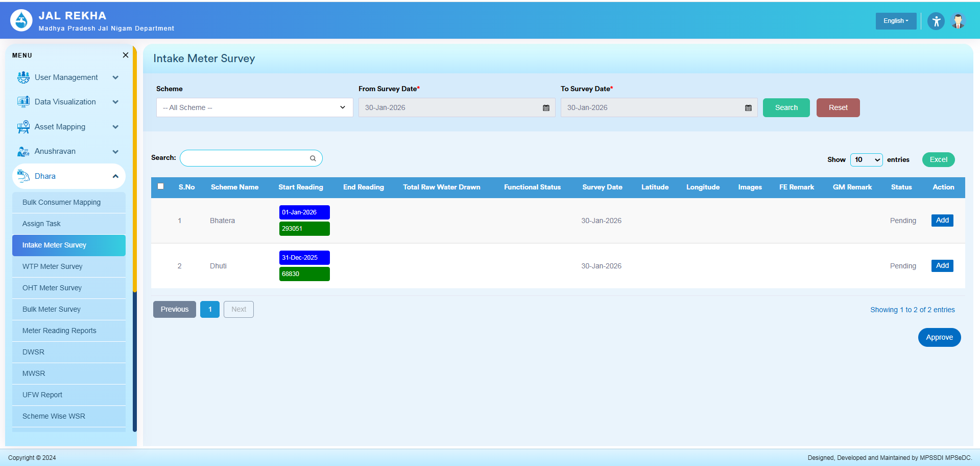
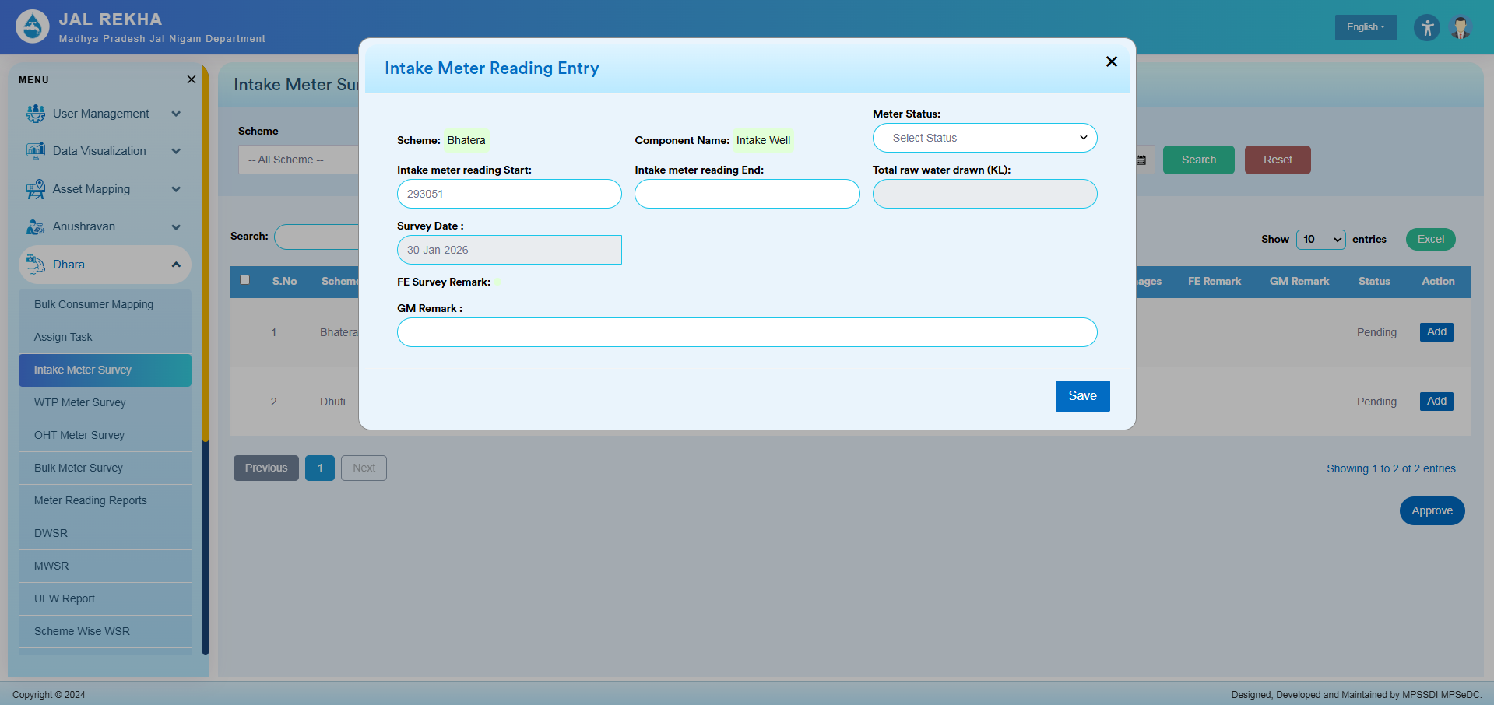

8. Sequence Diagram – Dhara Module Meter Reading Workflow

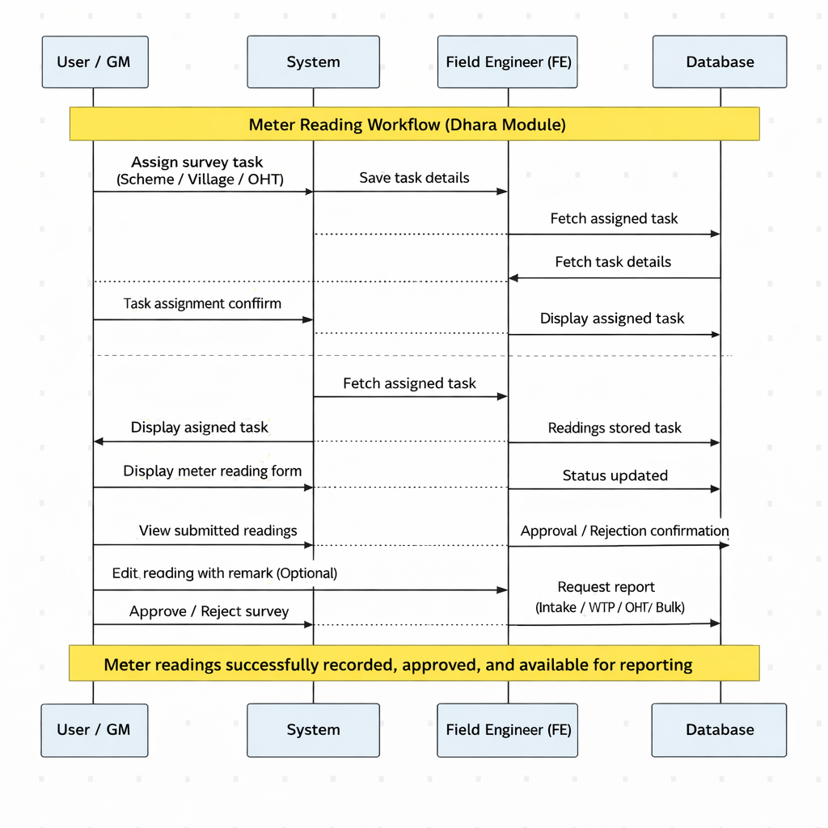
Scenario
Field Engineer (FE) receives a survey task assigned by the General Manager (GM), submits meter readings through the mobile application, system stores the data in the database, and GM reviews, edits (if required), approves the readings, and views reports through the web portal.
This sequence illustrates the interaction between:
- General Manager (GM / User)
- System (Web & Mobile Application)
- Field Engineer (FE)
- Database
Sequence Flow – Step by Step (Dhara Module)
1. Task Assignment (Web)
- GM → System: Assign meter survey task (Scheme, Village, OHT)
- System → Database: Save survey task details
- Database → System: Task assignment confirmed
- System → GM: Task assigned successfully
2. Task Fetch (Mobile)
- FE → System: Request assigned survey tasks
- System → Database: Fetch assigned tasks
- Database → System: Return task details
- System → FE: Display assigned survey task
3. Meter Reading Submission (Mobile)
- System → FE: Display meter reading form
- FE → System: Submit meter reading and survey data
(Intake / WTP / OHT / Bulk Meter)
- System → Database: Save submitted readings
- Database → System: Reading stored successfully
- System → FE: Submission confirmation
4. Review & Edit (Web)
- GM → System: Open submitted survey data
- System → Database: Fetch meter readings
- Database → System: Return reading details
- System → GM: Display submitted readings
- (Optional)
  - GM → System: Edit reading with remark
  - System → Database: Update reading and remark
  - Database → System: Update confirmed
5. Approval / Rejection (Web)
- GM → System: Approve / Reject survey
- System → Database: Update survey status
- Database → System: Status updated
- System → GM: Approval / Rejection confirmation

9. Reporting

- GM → System: Request meter reading / water supply report
- System → Database: Fetch approved data
- Database → System: Return approved readings
- System → GM: Display report (with Excel download option)

10. Screen Details(Mobile)
Survey Task List:
- Displays tasks assigned by GM
Meter Reading Survey Screen:
- Reading input fields
- Other survey data
- Submit action

11. Validations & Business Rules
- Survey task can be assigned only after mapping completion
- FE cannot edit or approve survey after submission
- GM remark is mandatory when editing readings
- Only GM-approved data is used for reporting

12. Reports
- Intake Meter Reading Report
- WTP Meter Reading Report
- OHT Meter Reading Report
- Bulk Meter Reading Report
- Daily Water Supply Report (DWSR)
- Monthly Water Supply Report (MWSR)
- UFW Report
- Scheme Wise WSR
- Village Wise MWSR
- Bulk User MWSR
Each report supports Excel download functionality.

13. Security & Access Control
- Role-based access enforced
- Mobile access limited to Field Engineers
- Edit and approval rights restricted to General Manager

14. Error Handling & Logging
- Validation messages displayed on UI
- Edit and approval actions logged with timestamp and user details

15. Conclusion
The Dhara Module follows a mobile-assisted and web-governed architecture ensuring accurate data capture, supervisory control, and reliable reporting for water supply monitoring under Jal Rekha.

